TAKING YOUR FIRST STEPS TO UMPIRING AT SPRING-KLEIN

Now that you have completed your Introductory Umpire Training, the next step is to work some games so that we can see how you perform and gain some valuable game experience. Many of you may still have questions on how to take the proper steps to request games, so this memo has been prepared to help you along.
The first thing you need to do is to acquire all of your required uniform and accessories and be ready to umpire a game when the opportunity comes. The items you must have before you umpire a game are as follows:
- Gray Slacks – Heather Gray or Charcoal Gray
  - While these do not have to be the expensive umpire slacks at first, they must be of proper fit and hemmed to a proper length (no cuffs).
- Umpire Shirt – Navy
  - While you will be working alone at first and can wear any color you like, once you qualify to work with a partner, you must have a Navy shirt as a default color. All umpires are required to have a Navy shirt available just in case your partner doesn’t have the other colors you do.
- Proper Color Undershirt
  - If you wish to cover all possible shirts, black, navy, red and white will do it. A red undershirt is required for a Navy Umpire Shirt. If the shirt has black trim stripes, black is worn. If the shirt has navy trim stripes, navy is worn. If the shirt has white trim stripes, white is worn.
- Black Belt
  - A 1-3/4” wide, heavy plain black belt is best for the long term. It can be patent leather or plain finish. Do not use woven, elastic or patterned belts. This belt will eventually need to hold your ball bags with many baseballs in them. A thin belt won’t hold up very well.
- Black field shoes
  - There are many brands available, specifically for umpires, but whether or not you purchase these, they must be able to be shined or hold a good shine after cleaning.
- Black socks
  - They need to be long enough that no one sees skin when you’re in motion. No ankle socks allowed.
- Cap & Ball Bag
  - A Blue or Black cap & Ball bag must be worn that matches your shirt scheme. Navy Umpire shirt = Navy Hat & Ball bag. Black or White trim stripes on your Umpire shirt = Black Hat & Ball bag.
- Accessories
  - Indicator for Balls / Strikes / Outs
  - Plate Brush
  - Stop watch, timer or some method for keeping accurate game time
  - Card holder / pen

DO NOT REQUEST GAMES UNTIL YOU HAVE YOUR UNIFORM!!!
All of those that completed the training are eligible to work T-Ball and Coach Pitch League games in the Metro level season. You are not eligible for tournament games at this time. You will be informed when this has changed.
These games will be posted on our website – sksa.com – in the Umpires section listed in the left hand navigation column. Once you click on the Umpires link, scroll down until you see the Schedules section and click on the Excel link Umpire Schedule Download. This will bring up an Excel spreadsheet that lists all games currently in our upcoming League and Tournament schedule.
Look for games under a blue banner that indicate a League Level game. See below for an example of something you might see:
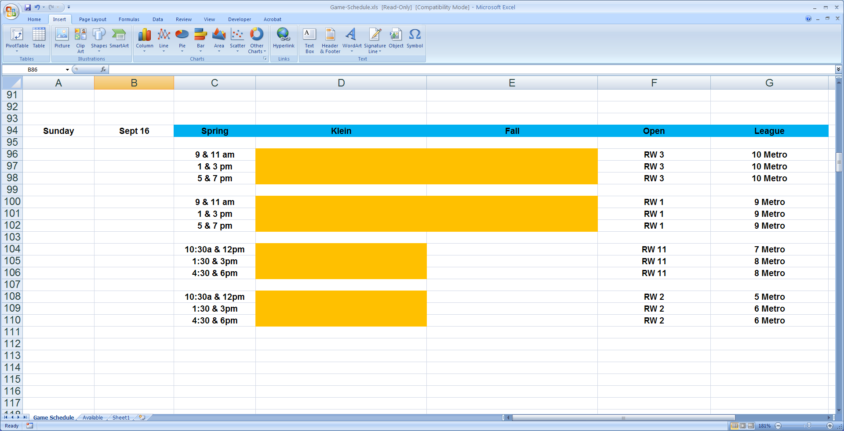
Notice the blue banner. This is your only eligible banner for games at this time. T-Ball are 5 Metro & 6 Metro. Coach Pitch are 7 Metro & 8 Metro. All other games on this example schedule are Kid Pitch games, so DO NOT request those games until you are approved for that level. Also, notice that your only eligible games will only have a spot for one umpire name.
All orange cells, without names, indicate games that are not yet assigned and you can request them – by e-mail only. DO NOT DELAY! Games are assigned quickly to the first qualified responders. You may request to umpire on for as many open dates as the schedule has eligible games. Check the schedule often! Games may become available.
There are rules posted in the Schedules section on Scheduling Procedures. Read them so that your requests are easy for the Scheduler to understand and limit your requests to five request dates per e-mail.
All game requests need to be e-mailed to umpires@sksa.com
DO NOT request dates that you do not intend to work! The quickest way to lose future opportunities is not holding up to your end of the bargain. Emergencies happen, but repetitive cancellations will compromise your ability to gain future work.
Keep it simple and never request specific games! All you have to do is say what you are requesting in the Subject line. For example:
- I am available on Sept 16 for two games – T-Ball or Coach Pitch
- I am available for all games on Sept 16, 18, 19 – T-Ball or Coach Pitch
You will receive a confirmation back from the scheduler once you have been scheduled. NEW UMPIRES - It is your responsibility to respond back to this scheduling e-mail stating “CONFIRMED” so it clear that you know that you are scheduled!
Also, check the schedule the day before your games. Sometimes field assignments change. In addition, brush up on the rules again. The SKSA park rules “The Yellow Book” are on the website in the Documents and Forms section.

SHOWING UP FOR YOUR GAME

Once you have a game(s) scheduled, make sure things go smoothly by:
- Arrive at least 30 minutes before your game is to start so you don’t feel rushed.
- Make sure your uniform is clean, unwrinkled, shoes are shined and you have everything you need for your game, including:
  - Ball Bag
  - Indicator
  - Plate Brush
  - Stop Watch or Timer
  - Card Holder / Pen
- Get your baseballs and game cards for your game(s). They will be located either in the Umpire Locker Room or the upstairs Board Room.
- Arrive to your field no later than 5 – 10 minutes prior to game time and meet with the team managers for your conference.
- Start the game on time and remember to start your clock!
- If you have questions, ask! We want to help you become a contributing member of our Umpire group.

UMPIRE EQUIPMENT SUPPLIERS

In case some of you need some contacts on where to buy your umpire equipment, here are some local businesses and some good online sources:
- Barcelona Sporting Goods – mention you’re an SKSA umpire and get 10% off
  - 9999 W. Sam
Houston Parkway North
Houston, TX 77064
713.464.8313

- Academy Sporting Goods – many Houston Locations – limited items

- http://ump-attire.com/

- http://honigs.com/

- http://www.theofficialschoice.com/

- http://www.homerunmonkey.com/homerun-umpire-equipment.html

- http://www.smitteez.com/index.php/categories/baseball-umpire-equipment-gear

- http://lestersupstatesports.com/

- http://www.umpirejoewest.com/products.htm

- http://www.gerrydavis.com/mm5/

- http://www.stripesplus.com/Default_v3.aspx

- https://www.refereescall.com/

- http://www.refshop.com/base-softball/baseball-softball-umpire-equipment.php

